Erik Wells
Dr. Wendy Smemoe
Linguistics 427
17 March 2012
Excellent Elocution, Dear
Introduction:
Language is fundamentally associated with identity, and can therefore be subject to intentional change. A person or a group that begins to recognize the identity language gives them has either the choice to maintain it, or to alter it so as also to alter or “enhance” their identity. Some of these desired identities might include any kind of identity that is different than the current one (for isolation’s sake), or a specific identity (like one seen to be refined) for enhancement’s sake. I believe that these latter two decisions and others can certainly affect many of the phonetic processes that normally occur in a language—and in this case American English—and yet there are still many processes that occur so naturally and subconsciously that they are never even noticed by the speaker at all, despite the decision to be different. Ultimately, I argue that those phonetic processes noticed and then countered are always undesired allophonic variation of a single phoneme. The speaker feels the need to “reconsolidate them” in order to change their identity in some way.
Discussion of Subjects and Stimuli:
Tabitha June Wells, whom I have chosen for this study, exemplifies both the desire to have perfect elocution and also to be different from others in Utah that have a different way of speaking. These attitudes simply reflect Tabitha’s personality and a culmination of other life experiences growing up. Listening for a moment it is easily apparent that she makes an effort to speak correctly; her syntax, for one, represents the most traditional English grammar available. So that I might discover how aware she is of phonetic processes—in order to prove the reconsolidation of the phoneme—I devised a story which exemplifies a range of common American English phonetic processes. I wanted to see which processes she has noticed and changed. So as to provide accurate data, Tabitha was asked to read the story the “very best she could”. This would allow for all phonetic processes that she felt the need to “improve” could come to light. The story goes like this (phonetic processes to be studied are keyed):
“My name is Nelson. I have a white cat named Cotton. Will you let me tell you about myself? I am top-boy, with my big car, and I am perfectly handsome. My kindness and friendship are glimpses of exactly these facts. I am also an interesting evening rogue. I rap, I have a map, now what do you think of that? Do you like my hat? One day, I went down to my friend down the street, Mr. Toad. I said, “Would you please play with me in the clean clay? We can also blow little bubbles and eat little apples. If not, we can do what you want, what you think is best. And, in case you’re hungry, would you eat my sandwich? Just then, and it was sudden, a car swerved to miss my white cat Cotton. It barely missed his white tail. It maddened Mr. Toad. But nothing happened to Cotton, thank Goodness! We each went to eat. The evening drew near. The next day, we heard about a suffering nursery, which was usually reasonably well-kept. It’s true! We want to try to help!” –footnote
https://docs.google.com/open?id=0B0eU6X1mO1mMRnFvTWN1T25zZUE

Stop-Stop Interactions
Consonant Clusters
Stop-Release
Nasal Plosion
Lateral Plosion
Palatalization
Vowel Elision after Primary Stress
Voicelessness of “l”

Data Analysis:
1. Stop-Stop interactions (Cruttendan 158)
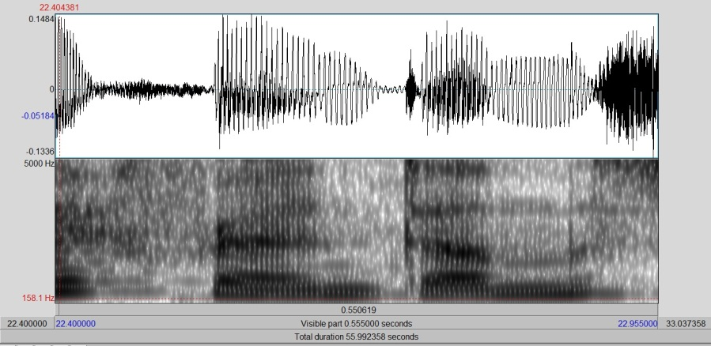
In 89% of all stop-stop interactions studied, the first consonant was unreleased, as is common in American English. This was true for consonants that took place at the same place of articulation and those that were of different places of articulation. The only instance where two consonants were distinctly articulated was when the consonants were in the same word: “kept”.
“friend down”

2. Consonant Clusters, (Cruttendan 237)
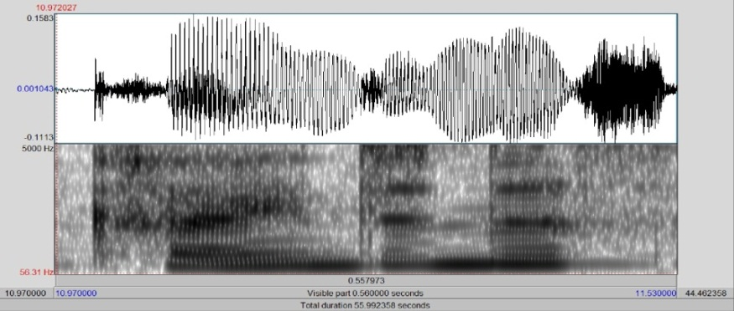
71% of all consonant clusters studied were not simplified, unlike the common trend in American English. Words like “kindness”, friendship”, “glimpses”, “exactly” and “perfectly” were all enunciated extremely clearly, emphasis being given to each sound particularly. “Handsome” and “next day” were the examples of where reduction did take place. The example of “kindness” above is an interesting phenomenon in and of itself: it was articulated to the point that there was noticeable insertion of a reduced vowel between the /d/ and /n/.
“kindness”

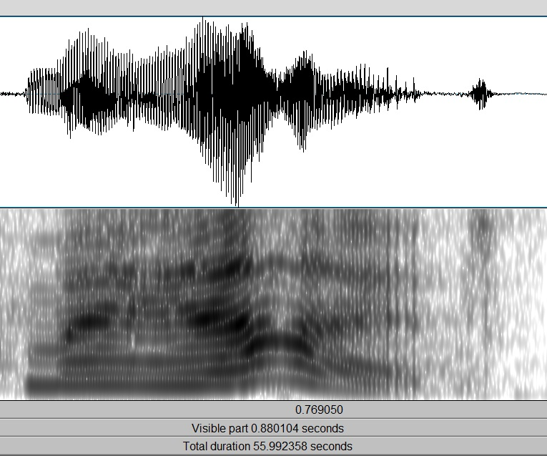
3. Stop-Release, (Cruttendan 157)
64% of all prepausal stops were released, with 36% of stops being nonreleased. Examples of released consonants included /p, t, d, g/, and examples of nonreleased cononants also included /p, t, d/.
Released “My hat”

4. Nasal Plosion (Olive 277)
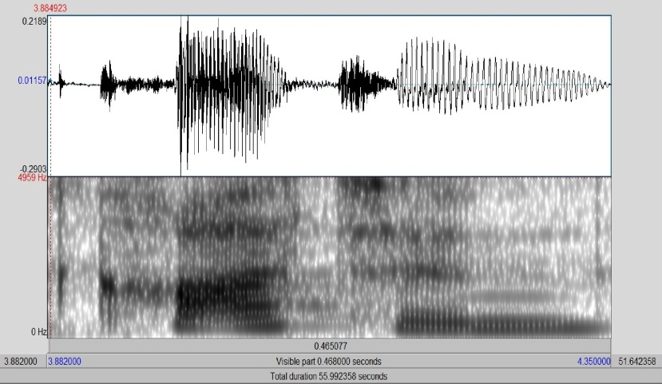
In all of the instances studied, the only word that was not pronounced with nasal plosion was the name “Cotton”. It was produced with a reduced vowel 100% of the time. All other words were produced with strong nasal plosion, including: “sudden”, “maddened” and “happen”.
“Cotton”
5. Lateral Plosion, (Olive 278)
Lateral plosion took place consistently after /t/, but never after /p, b/. In the word “little”, for example, there was always a reduced vowel inserted between /t/ and /l/.
“little”

6. Palatalization, (Olive 286)
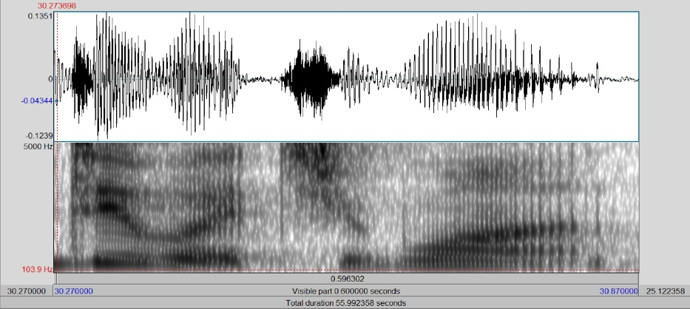
Palatalization occurred on 100% of all tokens studied. It occurred in sequences such as “what you”, “would you”, “case you”, “drew”, and “true”.
“do what you”

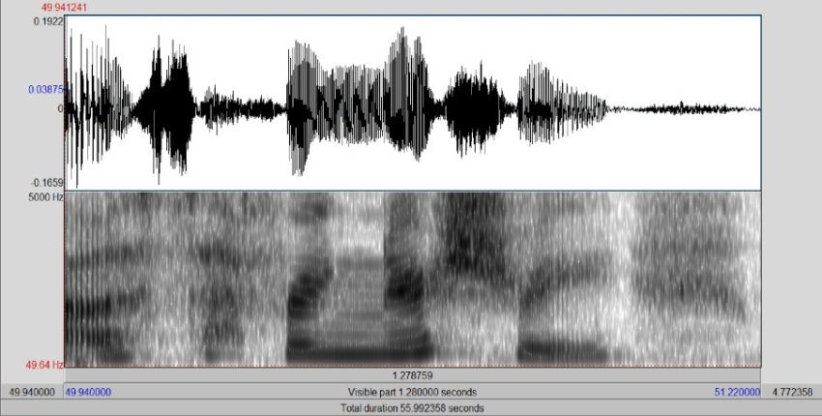
7. Vowel Elision after primary stress (Cruttendan 236, Olive 35)
Vowel elision occurred every time the rule was able to be applied, as seen in the examples: “evening”, “interesting”, “nursery”, “usually”, and “suffering”.

“suffering”
8. Voicelessness of “l” (Olive 285)
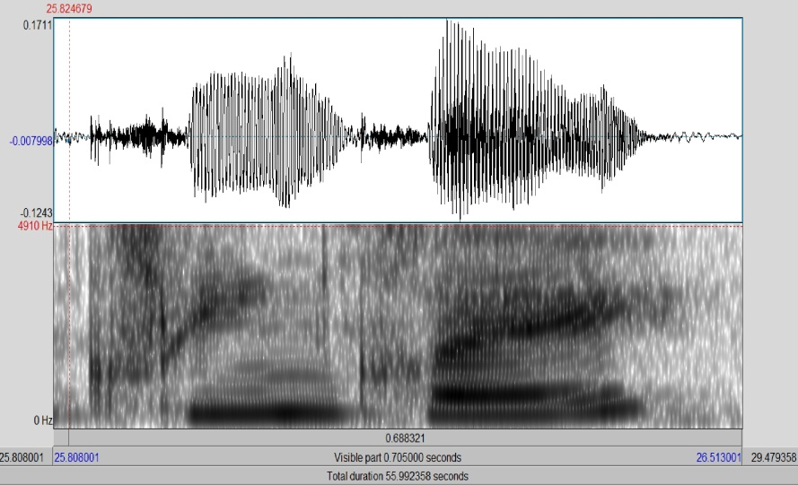
/l/ was voiceless in all of the locations where it is normally voiceless in American English phonotactics, as seen by the examples: “clean”, “clay”, “please”, and “play”.

Results
The data presented clearly prove that there are certain phonetic processes that Tabitha does not counteract—either because she is not aware of them, or because she does not consider them a threat. The data also suggest that there is a strong tendency to counter a phonetic process by the reconsolidation of a phoneme, as will follow below.
Proof of the lack of knowledge is seen in the voicelessness of /l/ before a voiced consonant word-initially. This is a process that happens without fail, apparently untouched by her desire to speak correctly. Knowledge of this phenomenon is unlikely, due to the fact that Tabitha has had no formal training in linguistics and therefore has never even heard of the concept of voicing and much less of its complementary distribution. Logically it follows that this process cannot even be considered for its correctness if it is unknown to her. A phonetic process such as this, occurring normally in the linguistic society she is a part of, will have thus room enough to exist and flourish without risk of being changed.
Vowel elision falls into the same category. Here we have an instance of a single vowel phoneme consistently deleted in its appropriate environment. The fact that the deletion occurs 100% of the time while society generally does likewise suggests that Tabitha has never become aware of the process. If it were something that she had learned to do and later become aware of the data would not be consistent; simply thinking about it would produce a differentiation in the data. Final proof is that all groups—including those that she tried to distance herself from phonetically—employ this process. She would have stopped doing it had she been aware of it.
In order to prove that there exists for Tabitha a reconsolidation of two allophones into one it must be proven that Tabitha knows that there exists a multiplicity of allophones per one phoneme; If she were not aware at some level—even subconsciously—she could not know to combine the two into one. Once that is established, it will be possible to show how it is done.
Evidence of Tabitha’s awareness of the phoneme existence appears in her articulation of stops word finally. She sometimes produces the stop released, and sometimes not, favoring the released allophone. The only suitable explanation for this is that she has heard and remembered that the phoneme /t/ is realized as a released consonant before vowels, which is the majority of the time. She also knows of the allophone of the unreleased stop, otherwise she would not replace it. The real question then becomes why Tabitha has chosen to favor one allophone above the other. I posit that the underlying form for /t/ in Tabitha’s mind is released because of its relative frequency in comparison to its allophonic variation, and therefore extended. This is so much the case that even in consonant clusters the /t/ which in most American’s speech would be deleted is perfectly audible.
Perhaps the most convincing evidence of the consolidation of two allophones into one phoneme is that fact that Tabitha allows phonetic processes to occur between two distinct phonemes. Just as Tabitha allows a phoneme with one allophone to be subject to changes because there is no knowledge that there were other allophones (in the examples of deletion of a vowel and the voicelessness of /l/), just so two distinct phonemes can blend together because their combination still represents two distinct phonemes in her mind. In other words, she can allow phonetic processes to apply so long as they remain obscured from her knowledge. All that is happening is that physical properties are altered without being noticed, while the two phonemes still reside in the mind. Palatalization and the unreleased first stop in a consonant cluster are all strong examples of this happening, because like as mentioned before they happen all of the time without fail.
Both of the examples of where Tabitha breaks with the common phonetic processes in lateral plosion and in nasal plosion interestingly occur when the phoneme /t/ is involved. It is possible that Tabitha is not aware that plosion is actually taking place, because that she is already used to there being only one phoneme for /t/. She extends the rule for /t/ into all situations, including the rules for plosion in American English. When plosion does not involve a /t/, however, the rule can proceed normally as natural phonetic processes dictate. This would support the idea that for Tabitha the collapsing of allomorphs into one is the correct thing to do.
The conclusion is simple: in order for Tabitha’s identity to be established the way she wants, she needs to reconstitute allophones that she is aware belong to the same phoneme. Another interesting and unintentional conclusion is that voicelessness of /l/ and vowel elisions are both phonetic processes that seem to be poorly known throughout American speakers of English. If Tabitha were unaware of them trying very hard to speak with one allophone for each phoneme, the likelihood of others likewise not noticing them is great.
Further study would reveal whether or not the phenomenon of two allophones merging into one again is a reality or not. It would be interesting to see how other native speakers of English that are also trying to personalize their identity change the way they speak phonetically, and if it involves a heavy change on the production of /t/. More study would also reveal how many people come to the realization that they do have a certain way of speaking and become self-conscious of it, as Tabitha seems to do.

Works Cited:
Cruttenden, Alan. Gimson’s Pronunciation of English, Sixth Edition. Oxford University Press, New York. 2001
Olive, Joseph P., Greenwood, Alice; & Coleman, John; Acoustics of American English., A Dynamic Approach Springer-Verlag, New York, 1993.

